## CHERRY IN LINE

**Chapter 5**

**Findings, Results, and Analysis**

5.2 Electrical Audit

5.2.1 Outdoor Electrical Equipment

The following Outdoor electrical equipment comprises Cherry Inline Booster electrical installation:

|  |  |  |  |
| --- | --- | --- | --- |
| Item | Description | MODEL | BRAND |
| 1. | 150 kVA Transformer (Utility supply)) |  |  |
| 2. | SILENT DIESEL GENERATOR110kVA/88Kw, 220/440V, 60hz | HGC-80 | HEXAGEN |
| 3. | MANUAL TRANSFER SWITCH | BW400EAG | FUJI |
| 4. | LIGHTNING ARRESTER WITH COUNTER | CDR-401 | CIRPROTEC |
| 5. | KILOWATTHOUR METER | V-62S | CANADIAN GENERAL ELECT. |

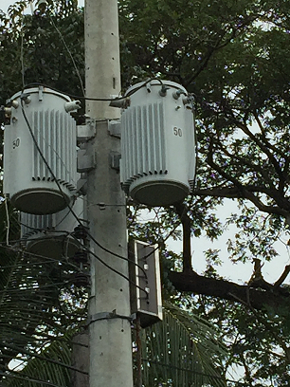 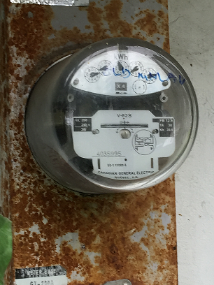 Utility Pole Mounted Transformer Kilowatthour Meter

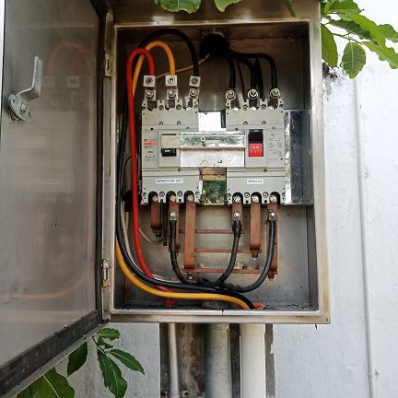 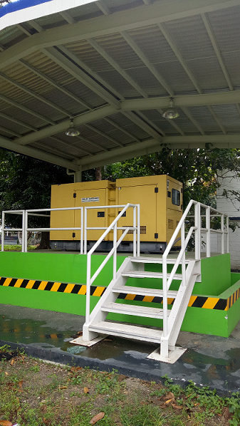 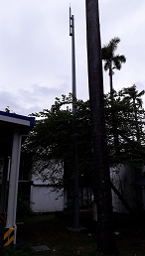

Manual Transfer Switch Genset house Lightning arrester

Make up some conclusions and recommendations